The Rain Song – Led Zeppelin (tuning D G C G C D)
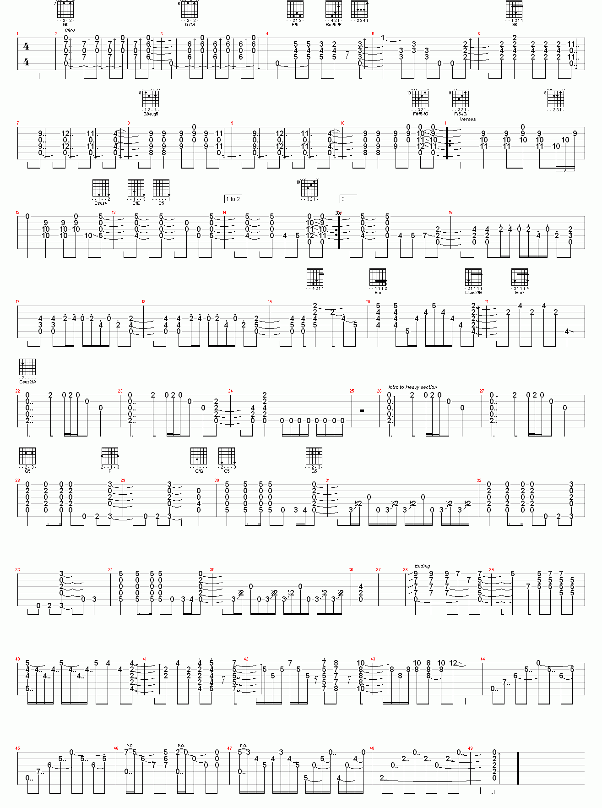
Page 1
Page 2

